
Parent Pack
Welcome aboard!
Thank you for encouraging your child to join the school trip to UKSA – we’re looking forward to welcoming them and their friends soon.

We like to say that UKSA is more than a school trip because:
- We’re based on the Isle of Wight, and you get here by ferry. It’s a bit like going abroad without the worry of passports.
- We’ve been delivering residential trips for over 35 years, so we know how to give everyone a great time.
- We focus on Skills4Life, helping your child to improve communication, resilience, determination and self-belief.
- Everyone is welcome at UKSA. If your child has additional needs or medical or dietary requirements, we’ll work with the school to ensure we have the right support in place.
- We deliver a fun trip, but we take safety very seriously.
- Plus, everything is included.

During their stay with us, your child will experience a variety of water sports - building skills and confidence and trying new things. There’s more information about the activities and day-to-day practicalities of the trip in this pack – please read on.
If you have any questions, please contact your trip leader rather than UKSA. We’re not being unfriendly, but it is important that the leader knows about concerns, issues and questions.

Contents
A day at UKSA  Water sports activities  What to pack  Food and accommodation | Where is UKSA?  Safety  FAQs for parents  What makes UKSA different?

Safeguarding policy
UKSA is committed to safeguarding children and adults and actively seeks to create a safe and welcoming environment. Doing nothing is not an option.
A day at UKSA
A typical day at UKSA looks like this:
Example Programme – your programme may be different to this example but will include 2 x 1:6 ratio activities and 2 x 1:15 ratio activities.
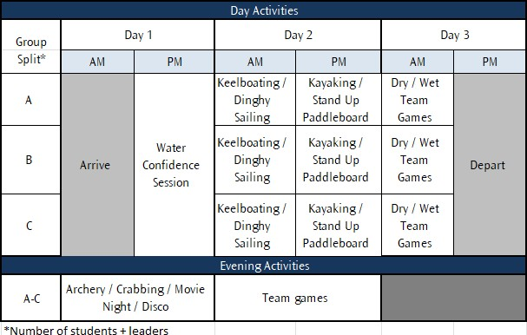

Your child will do one 3-hour water activity in the morning and a different one in the afternoon session. Concentrating on one activity allows young people to develop their skills without getting bored.
In the evening, we run activity sessions themed around team building and socialising. There’s more about activities on the following pages.
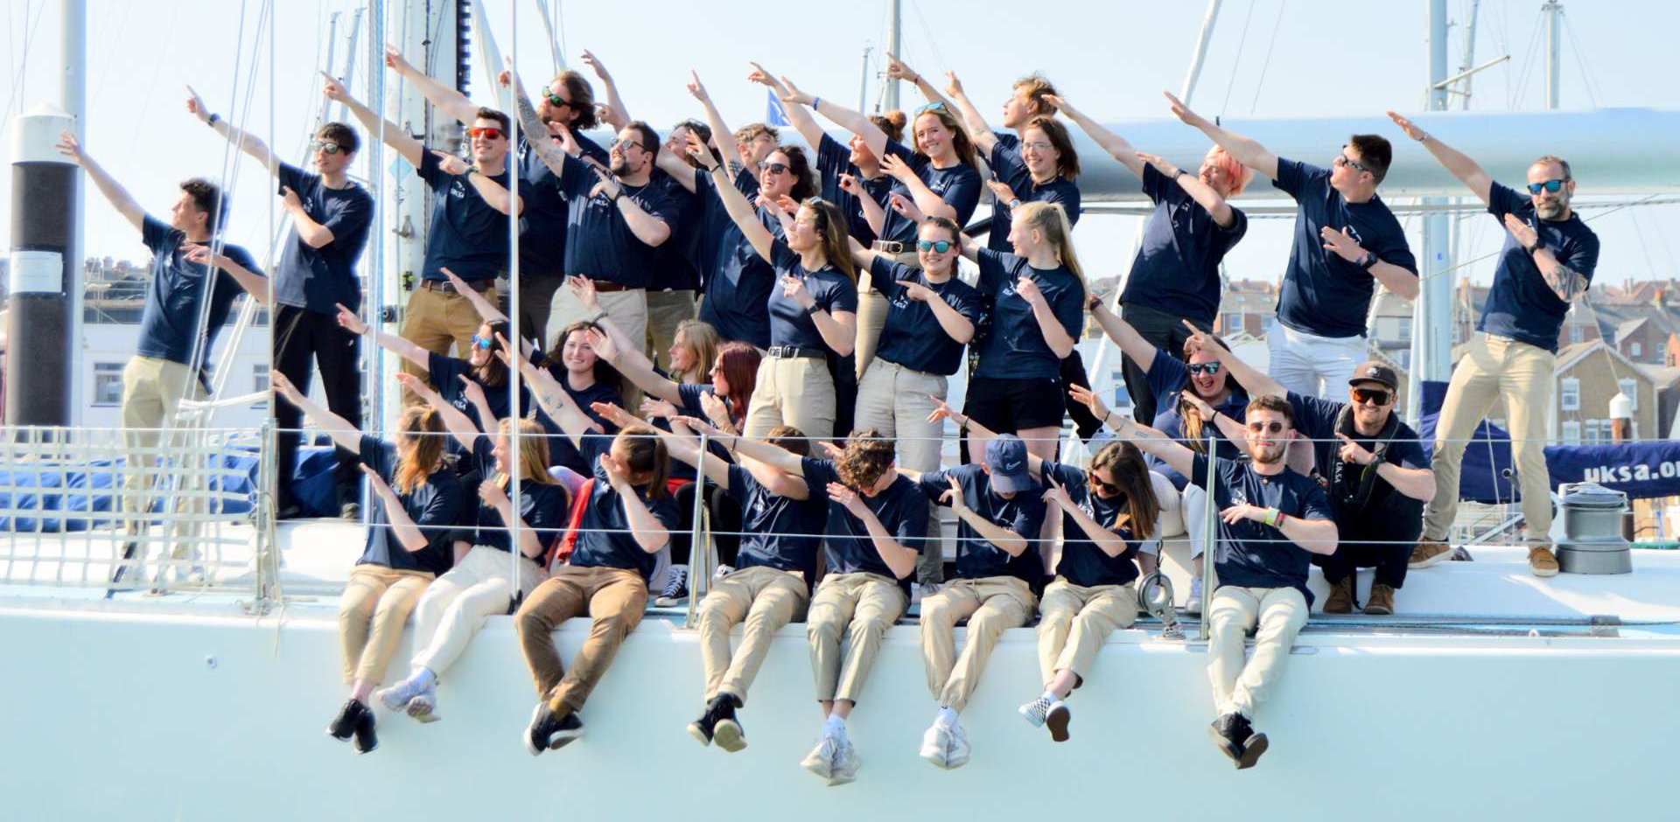


Water activities

Young people and adults taking part in our water sports activities wear wetsuits, buoyancy aids and helmets, which we provide. The level of activity is tailored to the age, experience and needs of the participants. These are some of the activities we offer at UKSA:
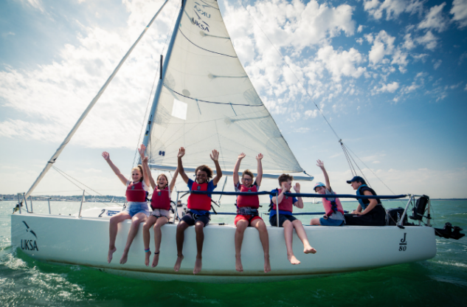
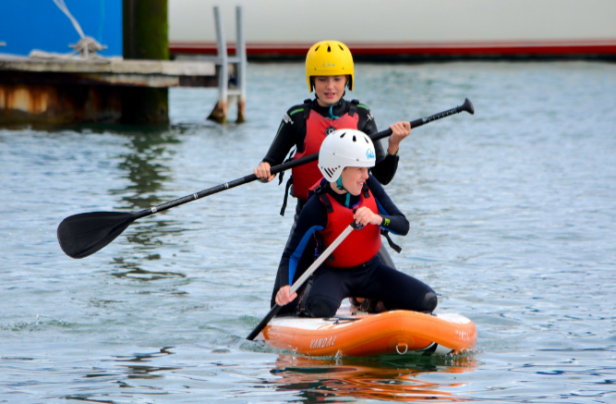






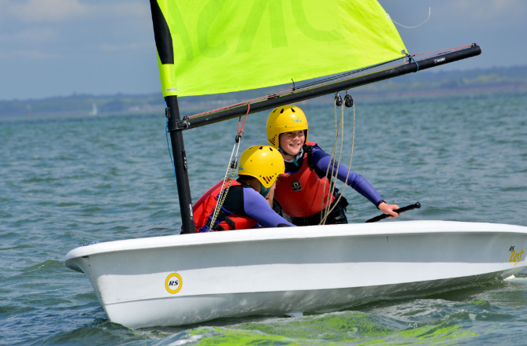
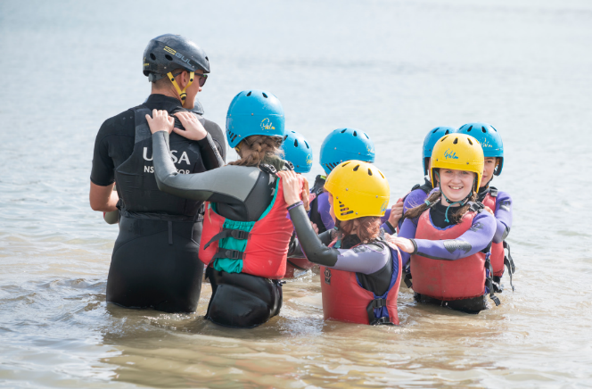
Stand-up
paddleboarding (SUP)
Stand-up paddleboards are big inflatable boards – they’re a great way to have fun and improve balance skills. We’ve even got a giant paddleboard for team games.
Keel Boating
Keel boats are larger than dinghies, they have two sails and a small engine and don’t capsize. The keel boats are sailed with an instructor and up to six young people so everyone can have a go.
Water confidence
We know that swimming ability and experience of the sea will vary, and many young people may be nervous. By playing games in shallow and deeper water, our instructors will get the children comfortable wearing the safety kit and confident in how it works.
Dinghy Sailing
Dinghies are small sailing boats crewed by two or three people, giving children control and building teamworking and communication skills. Dinghy sailing is wet, and capsizing is part of the fun.



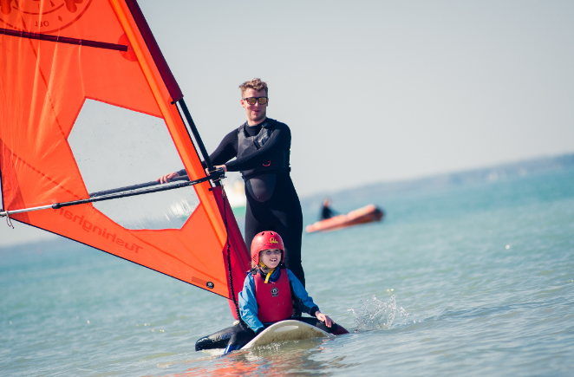
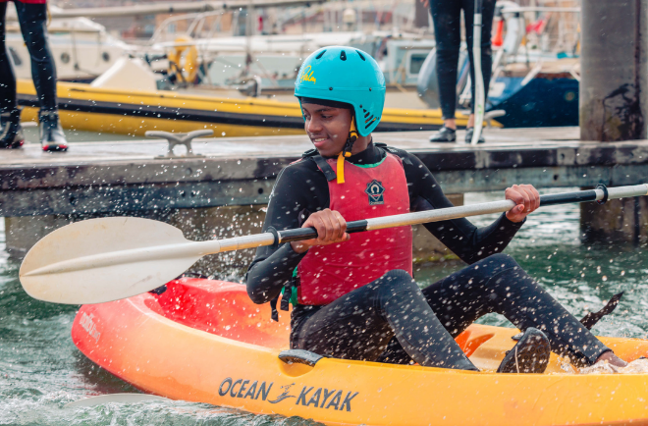
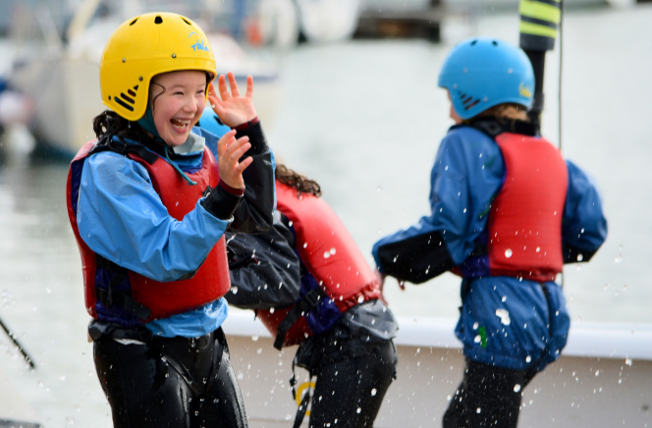
Waterproofs
Wet shoes
Beach towel
Water bottle
What you’ll wear & need
Wetsuit
Buoyancy aid
Helmet
Dry clothes
Windsurfing
Windsurf is a like a paddleboard with a sail on top, with one person per board. Windsurfing is a good way to build balance and resilience and is a whole lot of fun.
Kayaking
With two young people per kayak, this is a great activity for team working. Learning to steer and paddle in time with a partner helps boost confidence and increases the potential for fun.
Wet team games
A bit like water confidence, wet team games are about having fun in and around the water, building confidence and teamwork. We also do a raft build and race, which is a great test of teamwork and creative problem solving.
Evening Activities

Our evening entertainment team will keep the group engaged from 6.30pm to 8.30pm, before they are ready for bed!
Evening entertainments are themed around Calming, Energetic, Educational and Sociable activities – you choose what the group needs.
This might be crabbing or a disco, water polo in the swimming pool or team games in the sports hall, soft archery, mini climbing wall, a walk into Cowes or a quiet home cinema evening.

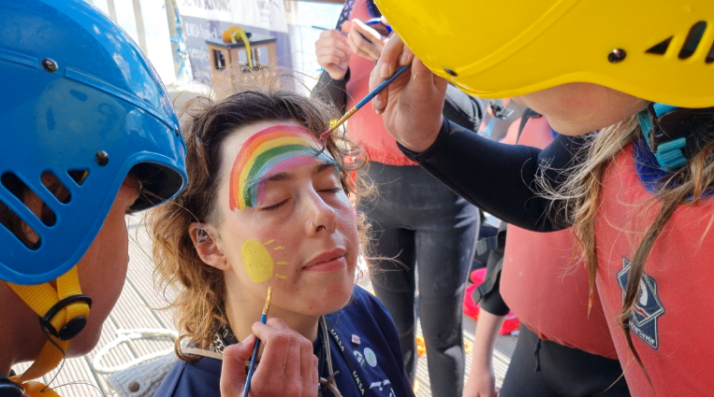
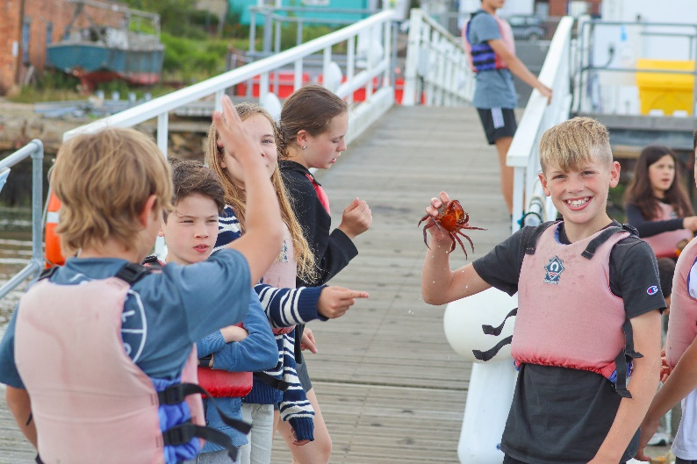
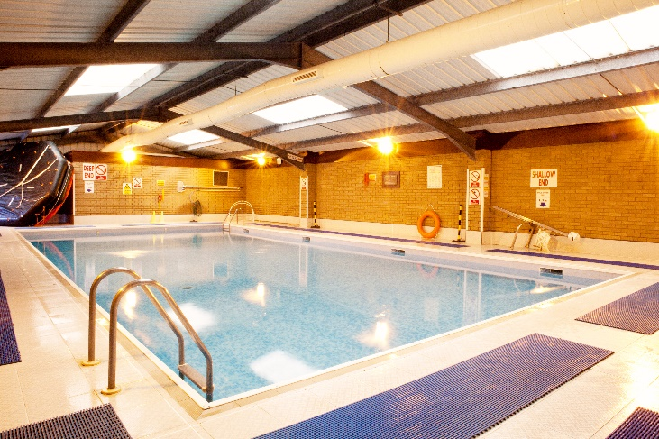
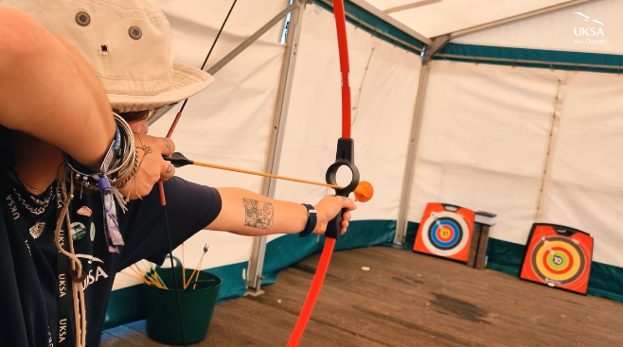
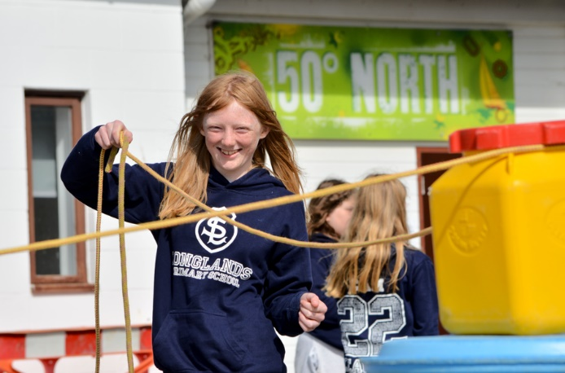

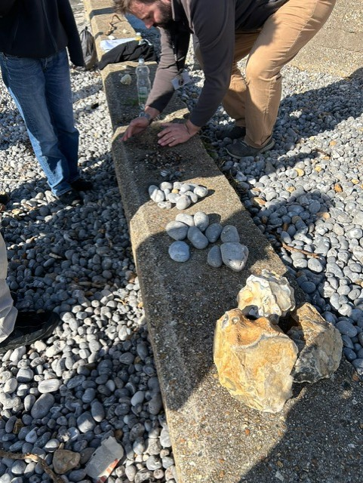

Packing for your adventure

This is a guide of what to pack for UKSA. Please think about the time of year (sun hat or woolly hat!) and any personal requirements.
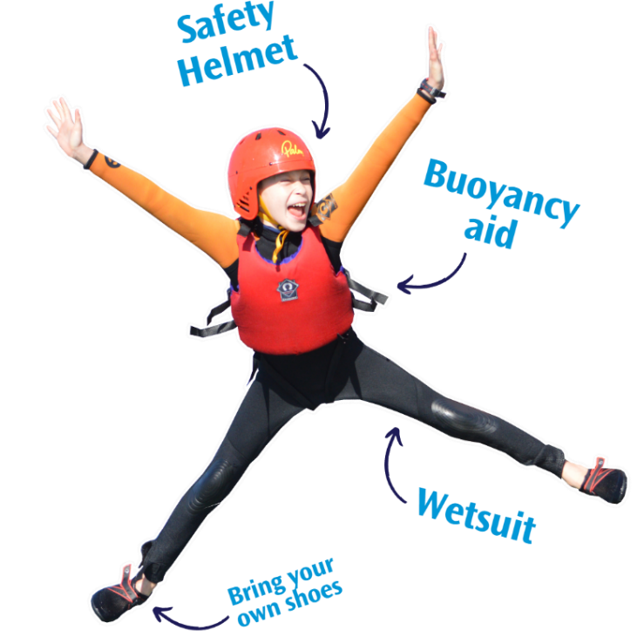
We provide
- Wetsuit to keep you warm
- Buoyancy aid to keep you afloat
- Safety helmet to protect your head
- Waterproofs (where needed)
- All bedding (sheets, duvet, pillow etc)
Essential items (your checklist)
Reusable drinks bottle
Lidded cup (if you want a hot drink)
2 towels (beach and shower)
Dry bag or plastic bag for wet clothing
Swimming costume
Clothes that can get wet – shorts, t-shirts (or rash vest)
Water footwear – old trainers or wetsuit shoes
Clothes and trainers/shoes for dry activities
Raincoat or cagoule
You don’t need
- Pillow or bedding
- Sleeping bag
- Specialist clothing
Pyjamas and slippers for the dorm rooms
Waterproof sun cream (Factor 50)
Sun hat or woolly hat
Glasses strap if bringing glasses/sunglasses
Toiletries
Remember
- Label or name all belongings
- Use a small bag, not a huge suitcase
- Clothes will get wet
- Don’t bring anything expensive or precious
- Don’t wear jewellery for activities
UKSA is not responsible for any loss or damage to items!
Food and sleep

A taste of what’s to come
After a busy day on the water, everyone needs wholesome, hearty food. Our kitchen team cook and make everything from scratch and can cater for fussy eaters, allergies and other dietary requirements.
Sample menu
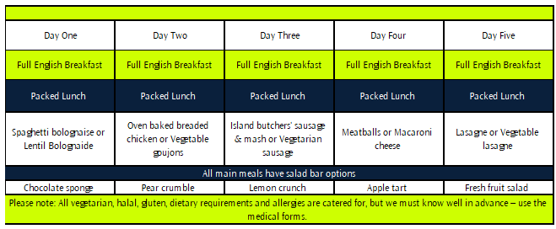
Each school/group will have set times for breakfast and dinner in the canteen (provided on arrival). Lunch is a sandwich/filled roll, fruit and crisps or snack, usually eaten outside or on location.
Bedtime
Each group has an accommodation block or deck with its own locked front door.
Accommodation is divided into several dormitory bedrooms that sleep 4, 6 or 8 in bunk beds. We will work with the school on a rooming plan that ensures girls, boys and adults have separate rooms.
We provide a sheet, duvet, duvet cover, pillow and pillowcase. The first challenge for the young people is to make their bed, and at the end of the trip they will strip their bed.
Spending money
Everything is included at UKSA, but your school may advise you to provide a small amount of spending money for ice creams. We have a vending machine and a small selection of gifts.

Where is UKSA?


UKSA is in the seaside town of Cowes on the north of the Isle of Wight.
The Isle of Wight (known as the Island) is located a couple of miles off the Hampshire coast. One of the sunniest places in England, the Island is a tourist destination and a great place for a holiday.
Cowes is a busy little town with a harbour, pebbly beach and bustling high street. UKSA is located about 15 minutes’ walk from the town centre, in a quiet residential area.

Ferries are part of the fun
They’ll travel to the Island by ferry from Southampton or Portsmouth, all included in the trip cost. The ferry takes one hour, and there’s no need for a passport!
For many young people, the ferry journey is one of the highlights of their trip. The crossing is usually smooth, and seasickness won’t be a problem.

Southampton route |  | Portsmouth route
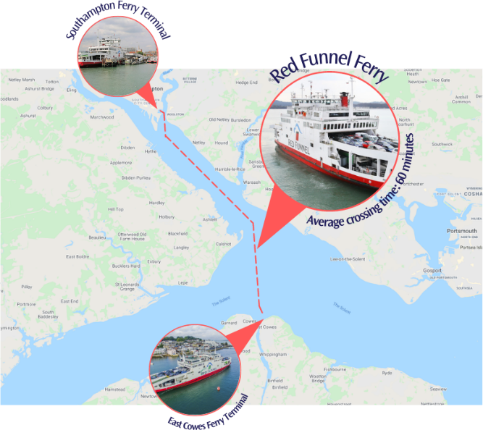 |  | 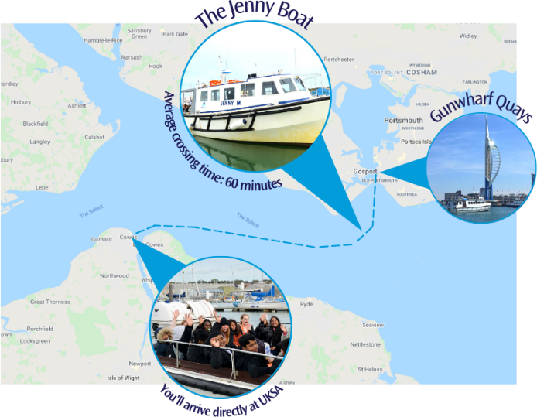

Our site

Our accommodation, classrooms, canteen and fleet of boats are located on our 4-acre site in Cowes. Most school trips won’t leave the site, but we do organise walking trips to the beach and recreation ground or coach/minibus to external sites on the school’s request.

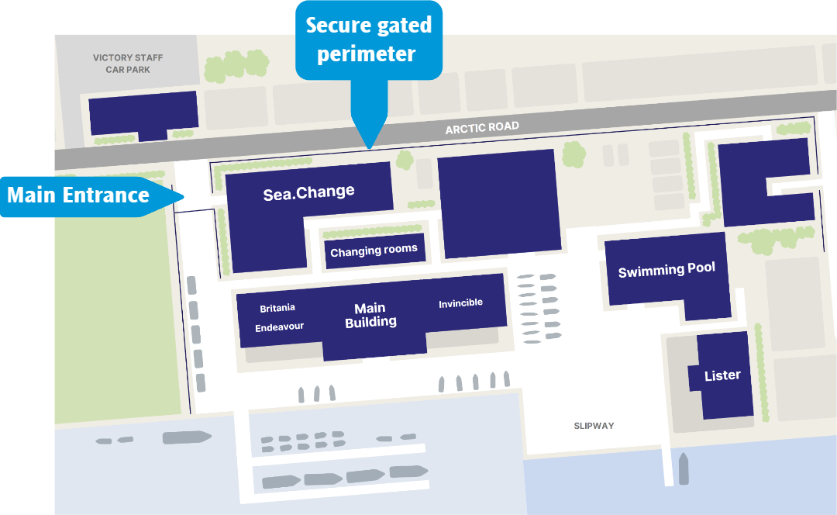
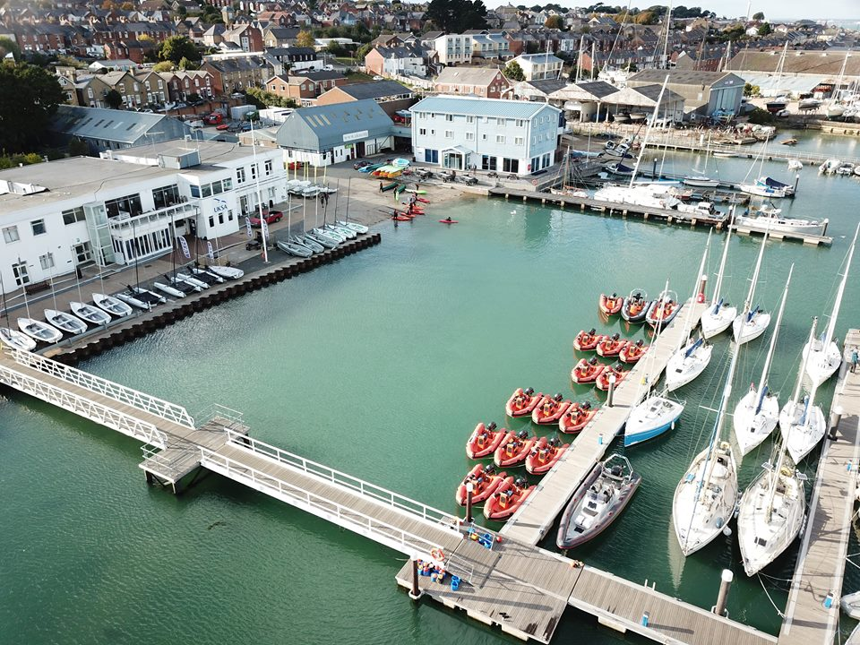
Dorm decks are located in the Sea.Change building and in the Britannia, Endeavour and Invincible blocks on the waterfront.
The canteen is in the main building. This is where breakfast and dinner are served.
The slipway is where the fun begins! The gently sloping ramp is the perfect place for water confidence games and where we launch kayaks and paddleboards.
Safety

We have been delivering sailing and watersports activities for adults and young people for more than 35 years, and the safety of all visitors and staff is of utmost importance.

Instructors
Each group has an ‘IC’ (instructor in charge) – an instructor who looks after the group. The IC will meet the teachers/leaders every day to ensure everyone knows what is happening.
Our instructors are all qualified in the activities they deliver, and are all DBS checked and have first aid training. The group may have different instructors for each activity, but they’re all friendly faces and the IC is always available to help.
We deliver watersports at a ratio of one instructor to six participants. Water confidence, wet team games and off-site activities are at 1:15 and evening activities are 1:20 ratio.
Medical and consent
We require medical, next of kin and consent information for everyone. This must be provided well in advance of arrival, so we can ensure that the watersports, welfare, kitchen and housekeeping teams are properly prepared for all needs. Your group leader will ask you to provide this information.
Remember no form, no fun!
Security
We have one site entry gate accessed with a key card. We have staff on site 24-7 and the site is covered by CCTV. Each accommodation block has a key card or pin code entry.
Teachers and group leaders
Teachers and adults accompanying the group know the young people best and will provide parental care during the trip.
The adults/leaders accompanying a group are responsible for the behaviour, discipline and supervision of their group. The leaders will look after the young people at mealtimes, overnight and outside activity sessions. UKSA staff run all activity sessions during the day and evening.
Leaders will accompany children with food allergies or dietary requirements to ensure they receive the correct food at mealtimes.
In an emergency, teachers will accompany the child to hospital, supported by our staff. If there is a problem, the school will contact you.
Our instructors and welfare team are always available for any young person with a problem or question.
More than a school trip

Skills4Life
UKSA is more than a school trip. Our programmes provide an opportunity for young people to have fun, be adventurous and learn new skills. To try new activities and be challenged in a safe, supportive environment. Activities are mapped to our skills for life framework:
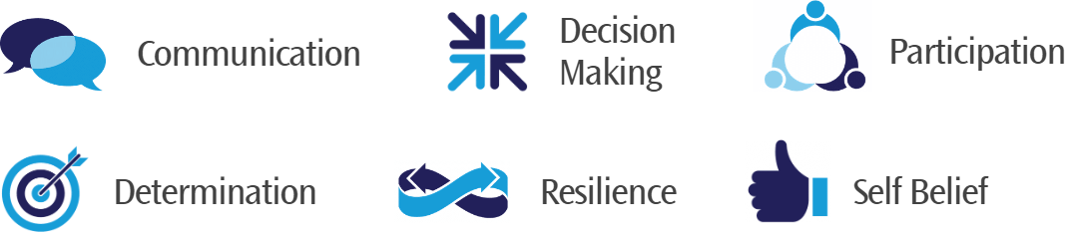

At the end of the trip, we give the young people a simple questionnaire to measure their personal development. Understanding the impact of the trip adds value for the young person and the school and helps UKSA to deliver our charitable aim of enhancing life skills through maritime training. We’ll share the results with the school or group a couple of weeks after the trip.
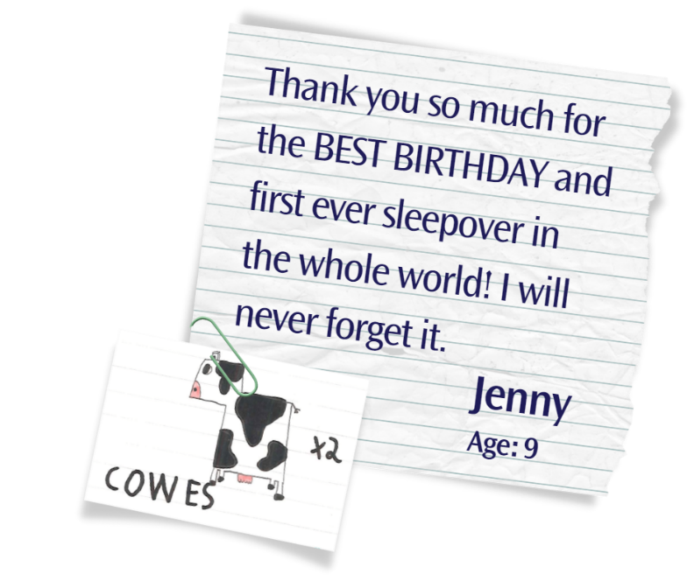
What UKSA is all about
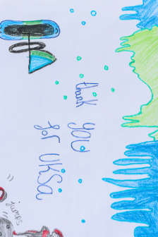
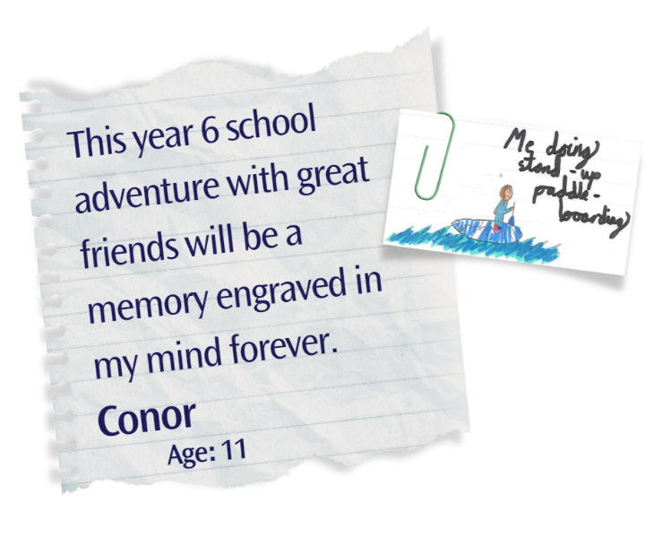
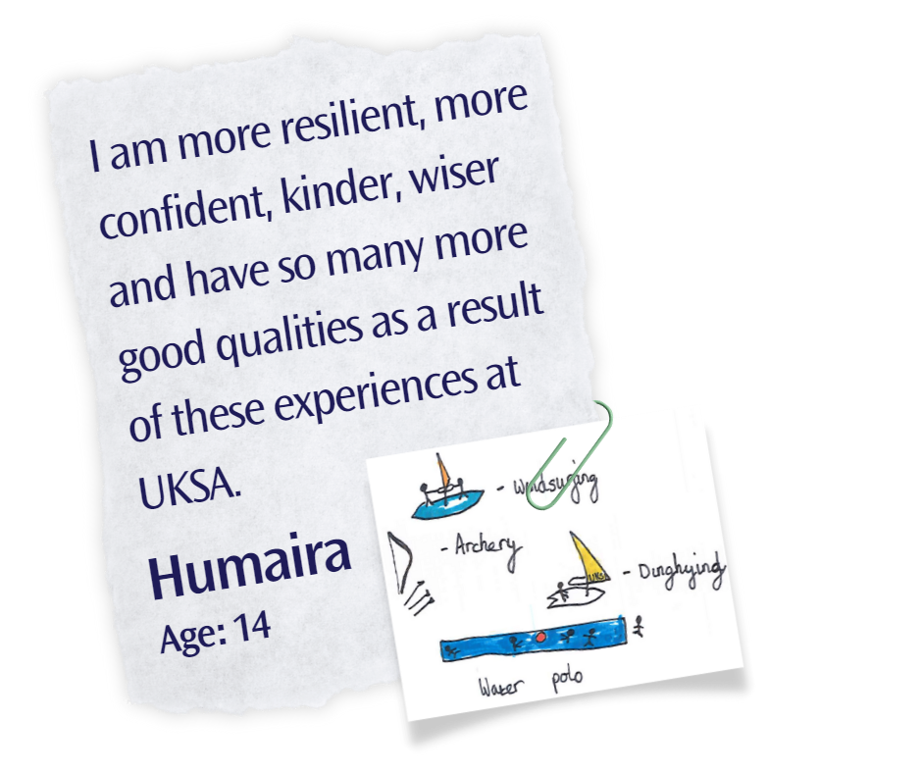
Frequently asked questions

How safe is it?
Everyone wears a buoyancy aid on the water – this keeps you afloat no matter how well you can swim. Everyone also wears a wetsuit to keep warm, even in the summer, and a helmet. We provide the buoyancy aid, wetsuit and helmets.
We have been welcoming groups of young people for over 35 years and are proud of our exemplary safety record. We have all the necessary safety systems and check in place on and off the water and are approved by external organisations like the Adventurous Activities Licensing Authority and the RYA.
Our aim is always for young people to have fun and to be safe.

What if my child can’t swim?
Please don’t worry. Everyone wears a buoyancy aid for all water activities. The buoyancy aid keeps the wearer afloat without needing to swim. We like to start trips with a water confidence and fun session to help the young people to get used to the water.

My child has additional needs
We want everyone to have a great time at UKSA. If your child has additional needs, health conditions or allergies, we’ll work with the school to provide the support or equipment your child needs. We can provide fridges to store medication.

What happens in the evenings?

Students are always fully supervised on residential activity trips, and there’s no time to be bored! We provide evening entertainments such as team games, water polo, crabbing, disco, knot tying or a home cinema night. These sessions finish at 8.30pm and teachers will decide on bedtime and lights out.

What is the food like?
All our food is freshly prepared on site with an emphasis on healthy eating. For breakfast there is a cooked option, as well as cereals, yoghurt, and fruit – students and guests can eat as much as they like! Lunch is a packed lunch.
Evening meals always feature fresh vegetables and a salad bar, with options for the main course including vegetarian or vegan and there is always an option for pudding.
We’re happy to make ketchup sandwiches if that is the only thing your child will eat!

Do you cater for food allergies and dietary requirements?
We can cater for students with food allergies or cultural and dietary requirements providing we know in advance. We’ll ask the school for this information as part of the medical consent process. We have risk assessments in place for allergies and regularly cater for a wide range of food needs.

What are the bedrooms like?
All accommodation is dorm rooms with bunk beds, sleeping between 4 and 8.
Rooms either have ensuite facilities or shared washrooms. Boys, girls and adults have separate bedrooms and bathrooms.
Every group has separate accommodation.

Is bedding provided?
Yes. Every bed has a duvet and pillow (hollow fibre, not feather) with a sheet, duvet cover and pillowcase. The bedding is washed between visits in a commercial laundry at 80 degrees and ironed at over 100 degrees.

What about pocket money?
Everything is provided at UKSA, so you child won’t really need pocket money. Your school will advise whether to bring money for an ice cream, for example.

Are there different schools on site?
UKSA is busy every week with up to five schools/groups plus older careers students. Every school has its own activity programme, allocated mealtimes and accommodation – there’s no mixing. All adults wear lanyards, ID cards and the main gate/reception are staffed 24-7.

What if my child gets upset or scared?
We know that a trip away from home and doing new activities can be challenging. Your child will be in a group with their friends and with teachers they know. We have a welfare team on site who can help, and a room called the ‘Mermaid Cave’ which is a safe space if it all gets a bit too much.
Our instructors won’t force anyone to do anything they don’t want to, but usually watching friends trying something new and enjoying it is enough to get the most reluctant young people involved.

What if my child has a period?
Don’t worry. If they don’t have period products, we have a ‘red box’ with everything they’ll need. They can ask a teacher, one of the water sports instructors or at reception at any time for a ‘red box’. Any friendly face at UKSA will happily help.

What about phones, consoles and expensive items?
Your school/group will have a policy about mobile phones and other devices. We discourage bringing expensive kit as it can get lost or broken, but we don’t ban electronic devices. However, we don’t allow any phones on the water or during activities.

What clothing is needed?
We provide wetsuits, safety helmets and buoyancy aids for all water activities.
Participants need clothing that can get wet such as: a swimming costume, shorts, t-shirt or rash vest to wear under wetsuit, and a pair of wetsuit shoes or old trainers for wearing in the water.
We recommend that all clothes are labelled.

Where can I buy wetsuit boots?
If you want to buy wetsuit boots or neoprene shoes instead of using an old pair of trainers, then these can be bought for around £10 online - they are often available for less in the supermarkets during the summer. Choose a style that fits snugly, or they could fall off.

What else is useful to bring?
Bring two towels – one for watersports and one for showering.
Pack a plastic bag or dry bag for wet clothes to go in for the trip home.
Everyone needs a water bottle.
If you want tea and coffee, bring a lidded mug.
What makes UKSA different?

UKSA is a charity
UKSA is a maritime youth charity (charity No.299248) and our Patron is HRH The Princess Royal.
We inspire and support children and young people to broaden their horizons through water-based adventures, education, and training for careers at sea. We are passionate about enhancing life skills, developing resilience, confidence and teamwork.
UKSA’s ambition is to work with more children and young people who need our help most, helping build positive futures and pathways into maritime employment.
We remove financial and social barriers by providing funding so that everyone from all walks of life can access our programmes. We rely on the generosity of donors and partners to help us.

Leave No Child Behind
We provide financial support to schools and groups through our Leave No Child Behind fund. Support is available for children in financial need and for groups from deprived areas. Please ask the Schools & Groups team for an application pack.
Can you help us? We rely on voluntary income to fund disadvantaged children - we welcome support from individual donors, trusts and companies. Maybe you could do a sponsored challenge at school, donate or become involved as a partner? Speak to our fundraising team fundraising@uksa.org for ideas and support.

Further education and more
We deliver fully funded Further Education courses (NCFE Level 3) for 16–18-year-olds.
We prepare people for careers in the superyacht, water sports and commercial maritime sectors with cadetships, apprenticeships and professional training.
We have funding available for 18–25-year-olds.

